Supplementary materials

Dominant height growth modeling of Aleppo pine (Pinus halepensis Mill.) in Beni Imloul forest, northern Algeria

Dalila Kherchouche^{1, *}, Mostefa Goubi², Tahar Sghaier³, Abdallah Bentouati¹, Khedidja Zeghichi¹, Said Slimani⁴

¹ Department of Agronomy Sciences, Institute of Veterinary and Agronomy Sciences, University of Batna 1. Street of Biskra, 05000 Batna - Algeria
² University of Khenchela Abbes Laghrour, 40000 Khenchela - Algeria
³ Forest Ecology Laboratory, National Research Institute of Rural Engineering, Water and Forests. Street of Hédi EL Karray, El Menzah IV, BP 10, 2080 Ariana - Tunisia
⁴ Department of Biological Sciences, Faculty of Biological and Agricultural Sciences, University Mouloud Mammeri of Tizi Ouzou. 15000 Tizi Ouzou – Algeria

* Corresponding author: Dalila Kherchouche - dalila.kherchouche@univ-batna.dz

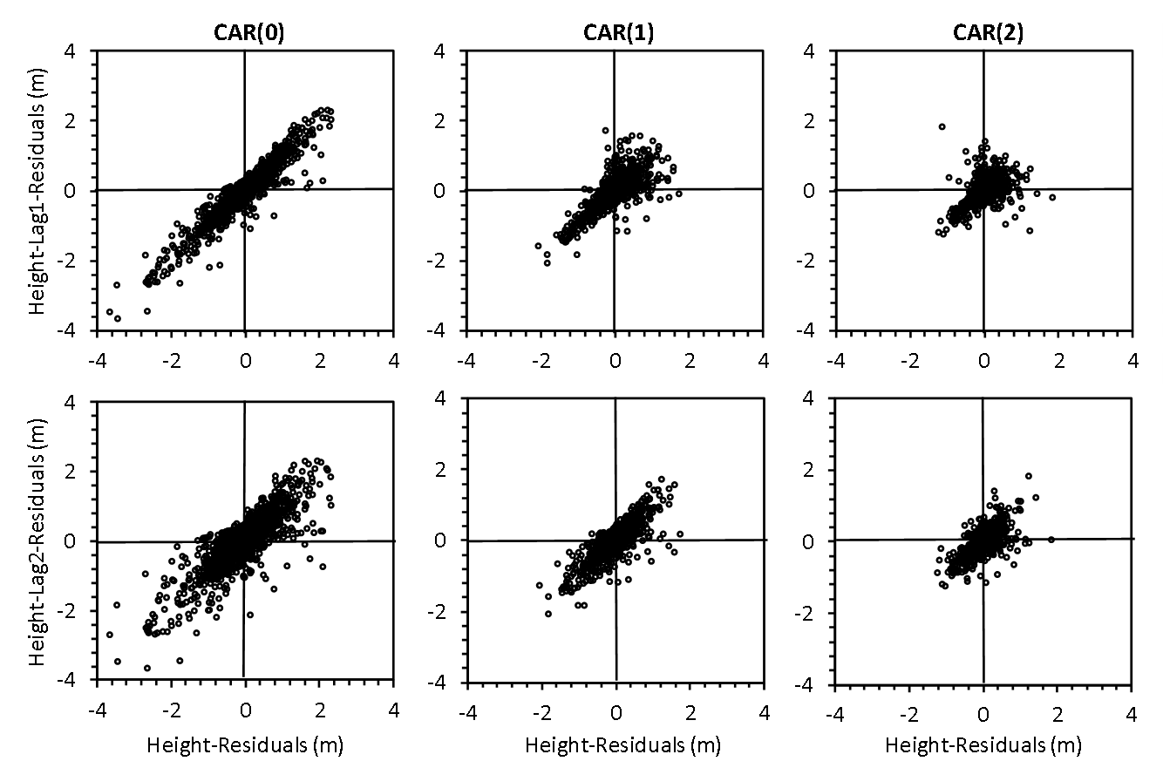

Figure S1 - Height-lag1-residuals and height-lag2-residuals versus height-residuals for model
M6 fitted without considering the autocorrelation parameters (first column), and using
continuous-time autoregressive error structures of first and second order (second and third
columns, resp.).

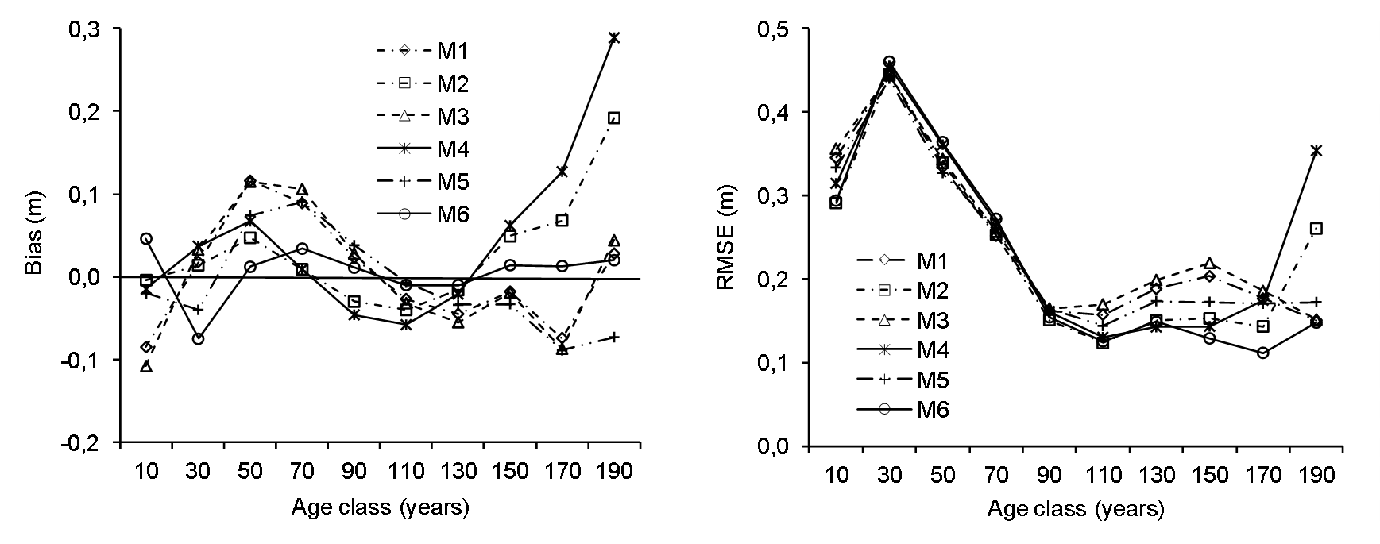
Figure S2 - Bias and root mean square error (RMSE) in height estimation for the six tested models by 20-year age classes.

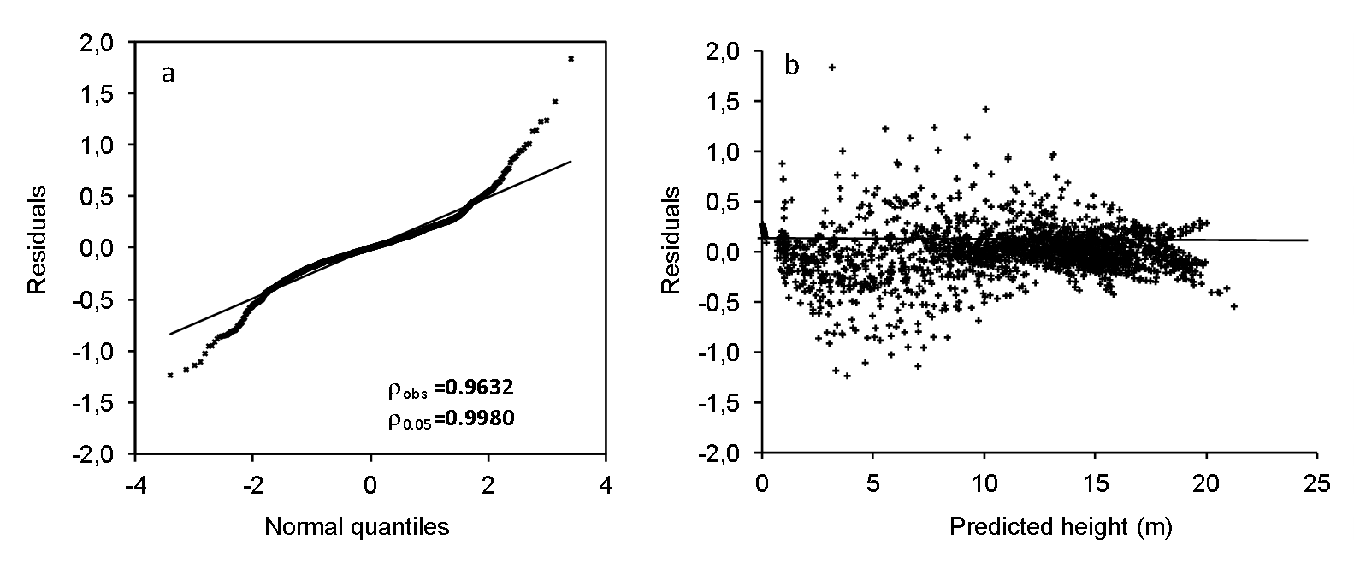
Figure S3 - QQ-probability plots of dominant height residuals (a) and residuals versus
predicted height (b) for model M6 (the GADA formulation of the Lundqvist-korf base
equation that considers two site-specific parameter) fitted with a second-order continuous-
time autoregressive error structure (CAR(2)).

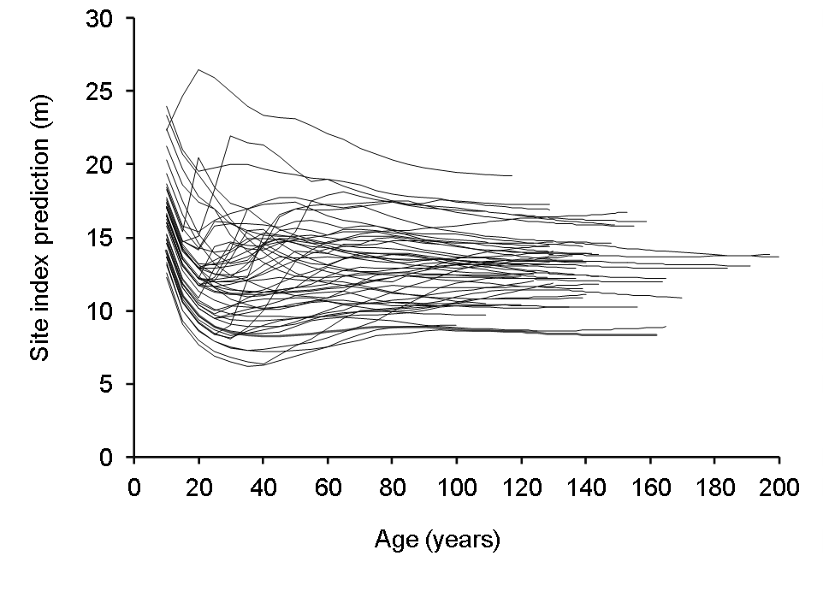
Figure S4 - Plot-level estimated site index trajectories against total age using model M6 and
The stem analysis data.

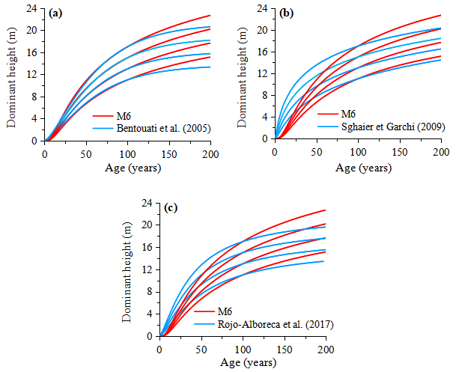
Figure S5 - The comparison between the site index curves of model M6 for heights of 11 m, 13 m, 15 m and 17 m at 100 years and other curves for the same species. (a) Bentouati et al. (2005), (b) Sghaier et Garchi (2009), (c) Rojo-Alboreca et al. (2017).

Table S1 - Base models and ADA/GADA formulations considered for height and diameter growth modeling.
Base equation | Parameter related to site | Solution for X with initial values (t₀,Y₀) | Dynamic equation | Model
Hossfeld  $$Y=\frac{a_{1}}{1+a_{2}t^{-a_{3}}}$$ |  | $$X_{0}=t_{0}^{b_{3}}\left(\frac{b_{1}}{Y_{0}}-1\right)$$ | $$Y=\frac{b_{1}}{1-\left(1-\frac{b_{1}}{Y_{0}}\right){\left(\frac{t_{0}}{t}\right)}^{b_{3}}}$$ | M1
Hossfeld  $$Y=\frac{a_{1}}{1+a_{2}t^{-a_{3}}}$$ |  | $$X_{0}=\frac{Y_{0}-b_{1}}{1-b_{2}Y_{0}t_{0}^{-b3}}$$ | $$Y=\frac{b_{1}+X_{0}}{1+b_{2}X_{0}t^{-b_{3}}}$$ | M2
Bertalanffy-Richards |  | $$X_{0}=\frac{-\ln\left(1-{\left(\frac{Y_{0}}{b_{1}}\right)}^{1/b_{3}}\right)}{t_{0}}$$ | $$Y=b_{1}{\left\{1-{\left[1-{\left(\frac{Y_{0}}{b_{1}}\right)}^{1/b_{3}}\right]}^{t/t_{0}}\right\}}^{b_{3}}$$ | M3
 |  | with $F_{0}=\ln\left(1-\exp\left(-b_{1}t_{0}\right)\right)$ |  | M4
Lundqvist-Korf |  | $$X_{0}=-\ln\left(\frac{Y_{0}}{b_{1}}\right)t_{0}^{b_{3}}$$ | $$Y=b_{1}{\left(\frac{Y_{0}}{b_{1}}\right)}^{{\left(\frac{t_{0}}{t}\right)}^{b_{3}}}$$ | M5
 |  |  | $$Y=exp\left(X_{0}\right)exp\left(-\left({b_{2}}/{X_{0}}\right)t^{-b_{3}}\right)$$ | M6

Table S2 - Distribution of the 167 sampled plots in four classes of fertility and summary statistics of the measured variables.
Fertility class | Number of plots | Variable | Average | Min | Max | STD
1 | 13 | I₀ (m) | 16.47 | 16.01 | 17.77 | 0.505
1 | 13 | Age (years) | 133 | 121 | 159 | 12.234
1 | 13 | N (stems/ha) | 221 | 170 | 290 | 37.256
1 | 13 | D_{g} (cm) | 39.82 | 33.1 | 44 | 3.095
1 | 13 | BA (m²/ha) | 27.71 | 22.16 | 35.71 | 3.735
1 | 13 | H_{g} (m) | 16.57 | 14 | 19 | 1.403
1 | 13 | H_{d} (m) | 18.82 | 17.85 | 20.05 | 0.712
1 | 13 | Volume (m³/ha) | 175.181 | 136.836 | 226.483 | 25.736
2 | 75 | I₀ (m) | 14.74 | 14.01 | 15.94 | 0.553
2 | 75 | Age (years) | 125 | 69 | 173 | 19.418
2 | 75 | N (stems/ha) | 223 | 150 | 390 | 47.059
2 | 75 | D_{g} (m) | 36.37 | 21 | 51.30 | 4.852
2 | 75 | BA (m²/ha) | 23.13 | 7.27 | 39.21 | 6.118
2 | 75 | H_{g} (m) | 15.29 | 10.50 | 19.00 | 1.813
2 | 75 | H_{d} (m) | 16.33 | 11.45 | 19.85 | 1.474
2 | 75 | Volume (m³/ha) | 142.987 | 48.902 | 245.806 | 39.854
3 | 65 | I₀ (m) | 13.26 | 12 | 13.98 | 0.559
3 | 65 | Age (years) | 129 | 68 | 196 | 23.772
3 | 65 | N (stems/ha) | 231 | 140 | 420 | 57.347
3 | 65 | D_{g} (m) | 34.81 | 24.80 | 54.80 | 5.426
3 | 65 | BA (m²/ha) | 21.85 | 9.69 | 37.69 | 6.423
3 | 65 | H_{g} (m) | 14.05 | 14.05 | 18.00 | 1.743
3 | 65 | H_{d} (m) | 14.91 | 10.58 | 18.20 | 1.575
3 | 65 | Volume (m³/ha) | 133.517 | 133.517 | 232.817 | 41.052
4 | 14 | I₀ (m) | 11.08 | 9.13 | 11.96 | 1.061
4 | 14 | Age (years) | 134 | 103 | 173 | 19.702
4 | 14 | N (stems/ha) | 305 | 170 | 517 | 111.929
4 | 14 | D_{g} (m) | 28.42 | 21.00 | 34.00 | 4.056
4 | 14 | BA (m²/ha) | 19.22 | 10.24 | 31,86 | 7.617
4 | 14 | H_{g} (m) | 11.81 | 8.73 | 13.50 | 1.644
4 | 14 | H_{d} (m) | 12.84 | 10.10 | 15.33 | 1.559
4 | 14 | Volume (m³/ha) | 110.764 | 59.63 | 187.941 | 45.533

