Appendix I

Ia. Monthly precipitation between fires occurrence in the study area

Ib. Sampling plots in Conguillio National Park (CNP).

In Araucaria forests, a complete consumption of the understory and low crown scorch could be observed.
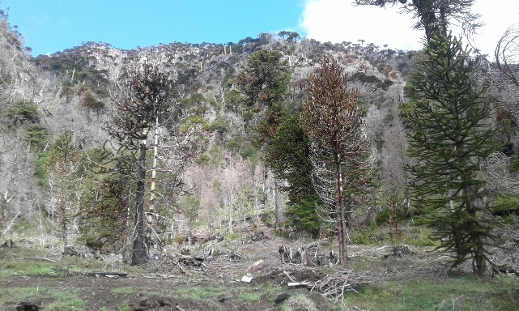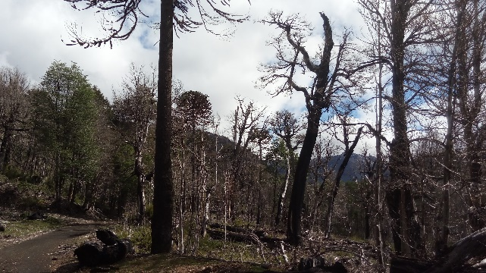
Ib. Sampling plots in Malleco National Reserve (MNR).
An incomplete vegetation consumption and fall of leaves and branches on the ground could be observed.

