Dataset of poplar plantations
F. Chianucci (fchianucci@gmail.com)
16/11/2020
The document illustrates basic features and contents available from the Dataset of tree inventory and canopy structure in poplar plantations in Northern Italy which was freely available from the following repository: http://dx.doi.org/10.17632/ycr7w5pvkt.1
The dataset is comprised by two tables, consisting of tree_inventory_dataset, which has tree-level structure data, and dcp_dataset, which has plot-level canopy structure data.
First we need to upload two libraries
library (tidyverse)
library (forestmangr)
Now we can upload the two tables:
tree<-read.csv("tree_inventory_dataset.csv")
dcp<-read.csv("dcp_dataset.csv")
Let’s look at the tables:
head(tree)
## plotID No. Row Row.Tree D H Vst Vcr Age
## 1 POM_2009_E10_A 1 1 1 33.0 22.98265 0.7138698 378.0312 10
## 2 POM_2009_E10_A 2 1 2 34.0 23.16915 0.7582427 411.8481 10
## 3 POM_2009_E10_A 3 1 3 35.5 23.37465 0.8273364 466.1739 10
## 4 POM_2009_E10_A 4 1 4 0.0 0.00000 0.0000000 0.0000 10
## 5 POM_2009_E10_A 5 1 5 35.0 23.31457 0.8039671 447.5772 10
## 6 POM_2009_E10_A 6 1 6 32.0 22.74451 0.6708475 346.0773 10
## Date Tree.sp
## 1 23/07/2019 42
## 2 23/07/2019 42
## 3 23/07/2019 42
## 4 23/07/2019 42
## 5 23/07/2019 42
## 6 23/07/2019 42
head(dcp)
## plotID GF FC CC CP LAI Date
## 1 POM_2009_E10_A 0.3343294 0.6656706 0.8907328 0.2526708 1.441591 2019-07-23
## 2 POM_2009_E10_A 0.3231883 0.6768117 0.8454090 0.1994268 1.603599 2019-07-23
## 3 POM_2009_E10_A 0.4032939 0.5967061 0.8931517 0.3319096 1.158883 2019-07-23
## 4 POM_2009_E10_A 0.3236445 0.6763555 0.8898637 0.2399336 1.494336 2019-07-23
## 5 POM_2009_E10_A 0.3605575 0.6394425 0.8216965 0.2218021 1.455824 2019-07-23
## 6 POM_2009_E10_A 0.3372624 0.6627376 0.8491404 0.2195194 1.514781 2019-07-23
The variable plotID is the primary key to join the tables.

Structure data
We can explore the individual tree diameter (D) variability according to plantation age (Age) or tree spacing (Tree.sp):
a<-ggplot(tree, aes(x=factor(Age),y=D))+
stat_boxplot(geom = "errorbar", width = 0.5) +
geom_boxplot()+
xlab("Age (years)")+
ylab("Diameter")
b<-ggplot(tree, aes(x=factor(Tree.sp),y=D))+
stat_boxplot(geom = "errorbar", width = 0.5) +
geom_boxplot()+
xlab(bquote(Tree~~Spacing~~(m^2)))+
ylab("Diameter")
a/b
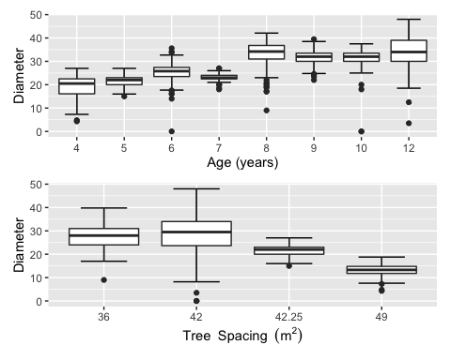
The two graphs were aligned using patchwork library
We can also analyze the plantation structure, by calculating plot-level data using the plot_summarise functionality of the forestmangr package
plot<-plot_summarise(df=tree,plot="plotID",plot_area=2500,dbh="D",th="H",age="Age",vwb="Vst") %>%
dplyr::select(-G,-Vst,-Indv)
head(plot)
## # A tibble: 6 x 10
## plotID Age plot_area D q H DH Indvha G_ha Vst_ha
## <fct> <dbl> <dbl> <dbl> <dbl> <dbl> <dbl> <dbl> <dbl> <dbl>
## 1 BOR_2008_A 12 2500 38.9 39.2 23.2 23.8 288 31.0 259.
## 2 BOR_2008_B 12 2500 33.8 34.4 22.0 23.8 288 23.9 199.
## 3 BOR_2008_C 12 2500 34.7 35.2 22.4 23.8 288 27.3 228.
## 4 BOR_2008_D 12 2500 29.6 29.7 21.5 23.4 288 19.6 163.
## 5 BOR_2011_A 9 2500 30.1 30.2 21.8 23.4 288 20.7 172.
## 6 BOR_2011_B 9 2500 32.5 32.6 22.6 23.4 288 24.1 201.
Now we can explore the (mean) tree diameter variability according to plantation Age or tree spacing Tree.sp:
c<-ggplot(plot, aes(x=factor(Age),y=D))+
stat_boxplot(geom = "errorbar", width = 0.5) +
geom_boxplot()+
xlab("Age (years)")+
ylab("Mean Diameter")
d<-ggplot(plot, aes(x=factor(Tree.sp),y=D))+
stat_boxplot(geom = "errorbar", width = 0.5) +
geom_boxplot()+
xlab(bquote(Tree~~Spacing~~(m^2)))+
ylab("Mean Diameter")
c/d
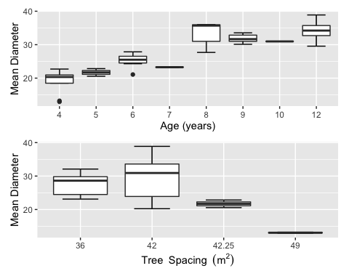
Similar stats can be calculated for either tree-level or plot-level structure data using height (H), tree stem volume (Vst), tree crown volume (Vcr). Here an additional example with basal area per hectare derived from plot-level data (G_ha). Results are ‘appended’ to previous graphs using patchwork library.
e<-ggplot(plot, aes(x=factor(Age),y=G_ha))+
stat_boxplot(geom = "errorbar", width = 0.5) +
geom_boxplot()+
xlab("Age (years)")+
ylab(bquote(Basal~~area~~(m^2~~ha^-1)))
e+(c/d)
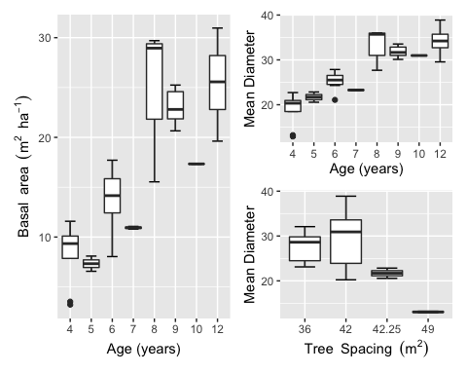

Canopy data
The dataset contains canopy structure data from 12-20 measurements (see graph below) collected in a grid using digital cover photography (DCP), following the protocol by Chianucci (2020)
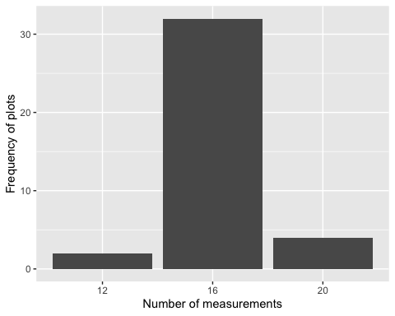
Once again here we can explore image-level variability of foliage cover (FC) according to plantation Age or tree spacing Tree.sp
f<-ggplot(dcp, aes(x=factor(Age),y=FC))+
stat_boxplot(geom = "errorbar", width = 0.5) +
geom_boxplot()+
xlab("Age (years)")+
ylab("Foliage cover")
g<-ggplot(dcp, aes(x=factor(Tree.sp),y=FC))+
stat_boxplot(geom = "errorbar", width = 0.5) +
geom_boxplot()+
xlab(bquote(Tree~~Spacing~~(m^2)))+
ylab("Foliage cover")
f/g
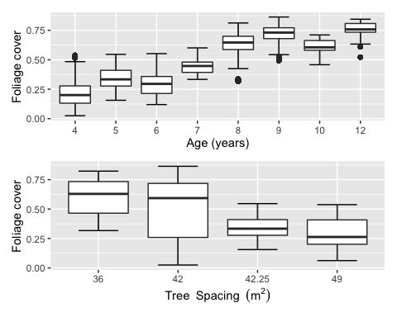
But we can also calculate plot-level canopy stats and observe the plot-level variability of foliage cover (FC) according to plantation Age or tree spacing Tree.sp:
First I need to calculate mean canopy attributes by plot (plotID):
dcp.plot<-dcp %>%
group_by(plotID) %>%
select(where(is.numeric)) %>%
summarise_all(mean)
head(dcp.plot)
## # A tibble: 6 x 8
## plotID GF FC CC CP LAI Age Tree.sp
## <fct> <dbl> <dbl> <dbl> <dbl> <dbl> <dbl> <dbl>
## 1 BOR_2008_A 0.198 0.802 0.908 0.116 2.32 12 42
## 2 BOR_2008_B 0.286 0.714 0.846 0.158 1.92 12 42
## 3 BOR_2008_C 0.256 0.744 0.882 0.156 1.93 12 42
## 4 BOR_2008_D 0.230 0.770 0.906 0.149 2.04 12 36
## 5 BOR_2011_A 0.329 0.671 0.765 0.123 1.90 9 42
## 6 BOR_2011_B 0.214 0.786 0.881 0.108 2.32 9 42
And now I can redo the boxplots at plot-level:
h<-ggplot(dcp.plot, aes(x=factor(Age),y=FC))+
stat_boxplot(geom = "errorbar", width = 0.5) +
geom_boxplot()+
xlab("Age (years)")+
ylab("Mean foliage cover")
i<-ggplot(dcp.plot, aes(x=factor(Tree.sp),y=FC))+
stat_boxplot(geom = "errorbar", width = 0.5) +
geom_boxplot()+
xlab(bquote(Tree~~Spacing~~(m^2)))+
ylab("Mean foliage cover")
h/i
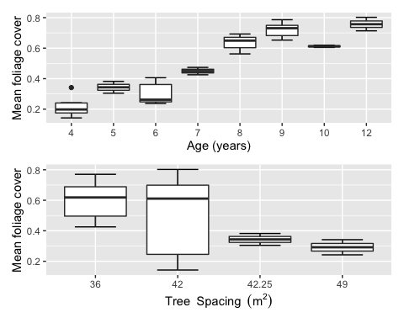

Join structure and canopy data
With plot-level structure and canopy data, we can join the two tables:
plot %>% left_join(dcp.plot,by="plotID")
Now I can analyze the relationships between structure and canopy data, as for example:
library(ggpmisc)
DF<-data.frame(df)
y<-DF$FC
x<-DF$G_ha
my.formula<-y~x
j<-ggplot(df,aes(x=G_ha,y=FC,color=Age))+
geom_point()+
geom_smooth(method="lm")+
stat_poly_eq(formula = my.formula,
aes(label = paste(..eq.label.., ..rr.label.., sep = "~~~")),
parse = TRUE)+
ylab('Foliage cover')+
xlab(bquote(G~(m^2~ha^-1)))
k<-ggplot(df, aes(x=factor(Age), y=LAI))+
stat_boxplot(geom = "errorbar", width = 0.5) +
geom_boxplot()+
xlab("Age")+
ylab("Leaf area index (LAI)")
l<-ggplot(df, aes(x=factor(Tree.sp), y=LAI))+
stat_boxplot(geom = "errorbar", width = 0.5) +
geom_boxplot()+
xlab("Tree spacing")+
ylab("Leaf area index (LAI)")
j+(k/l)
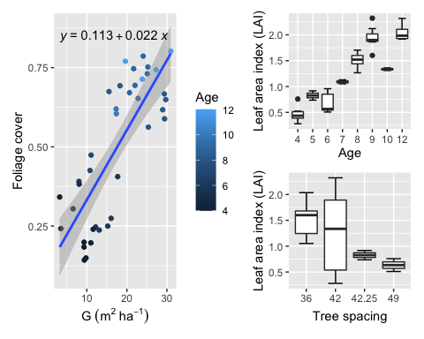
Here we used the stat_poly_eq of the ggpmisc package to plot the regression formula on the graph

