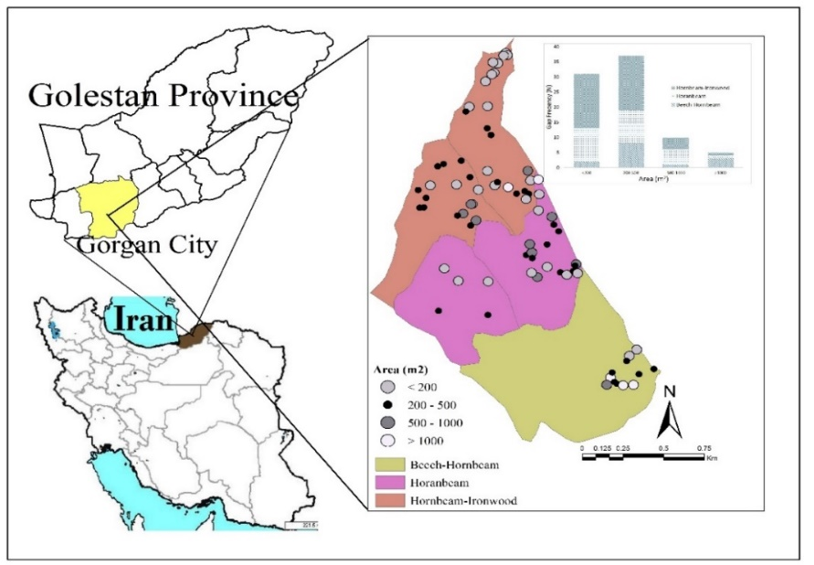

Fig. 1 Study area within the 2 district of the Shastkalateh experimental Forest in northern Iran

