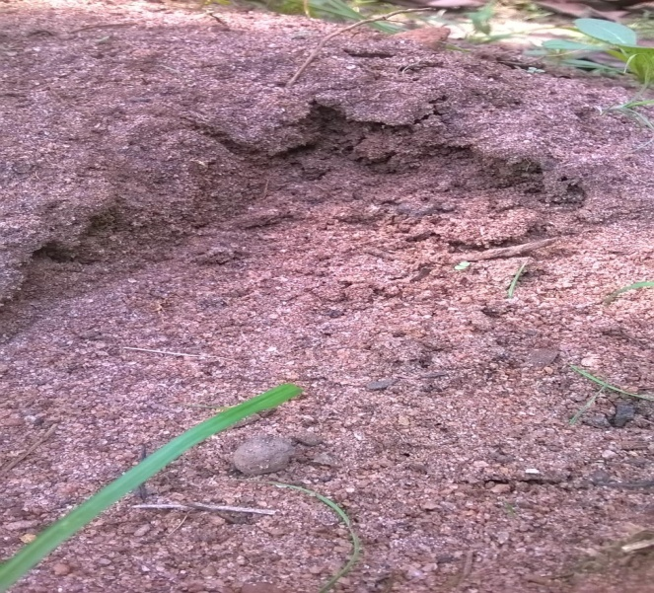
Fig 1: Top soil from the nursery

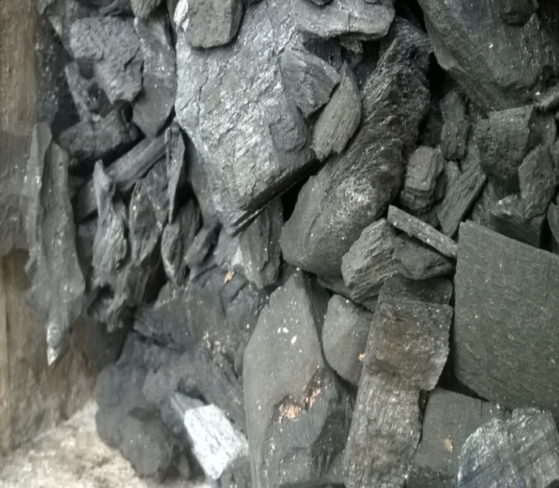
Fig 2: Biochar before pounding

